**Requirements**  
Python

**Steps:-**

1.Check if python is installed or not :-

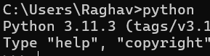  
  
If not installed follow:- [#2 Python Tutorial for Beginners | Python Installation | PyCharm](https://youtu.be/CScxy0294SE?feature=shared)  
  
2.Install flask  
pip install flask  
  
3.Create a new folder   
  
4.Create a new file “app.py”  
  
5.Inside a folder create another new folder “templates”  
templates is used to store HTML Files

6.Create a new HTML File in templates

7.In app.py   
Import flask using :- from flask import Flask  
  
8.Run the flask app :-

python app.py